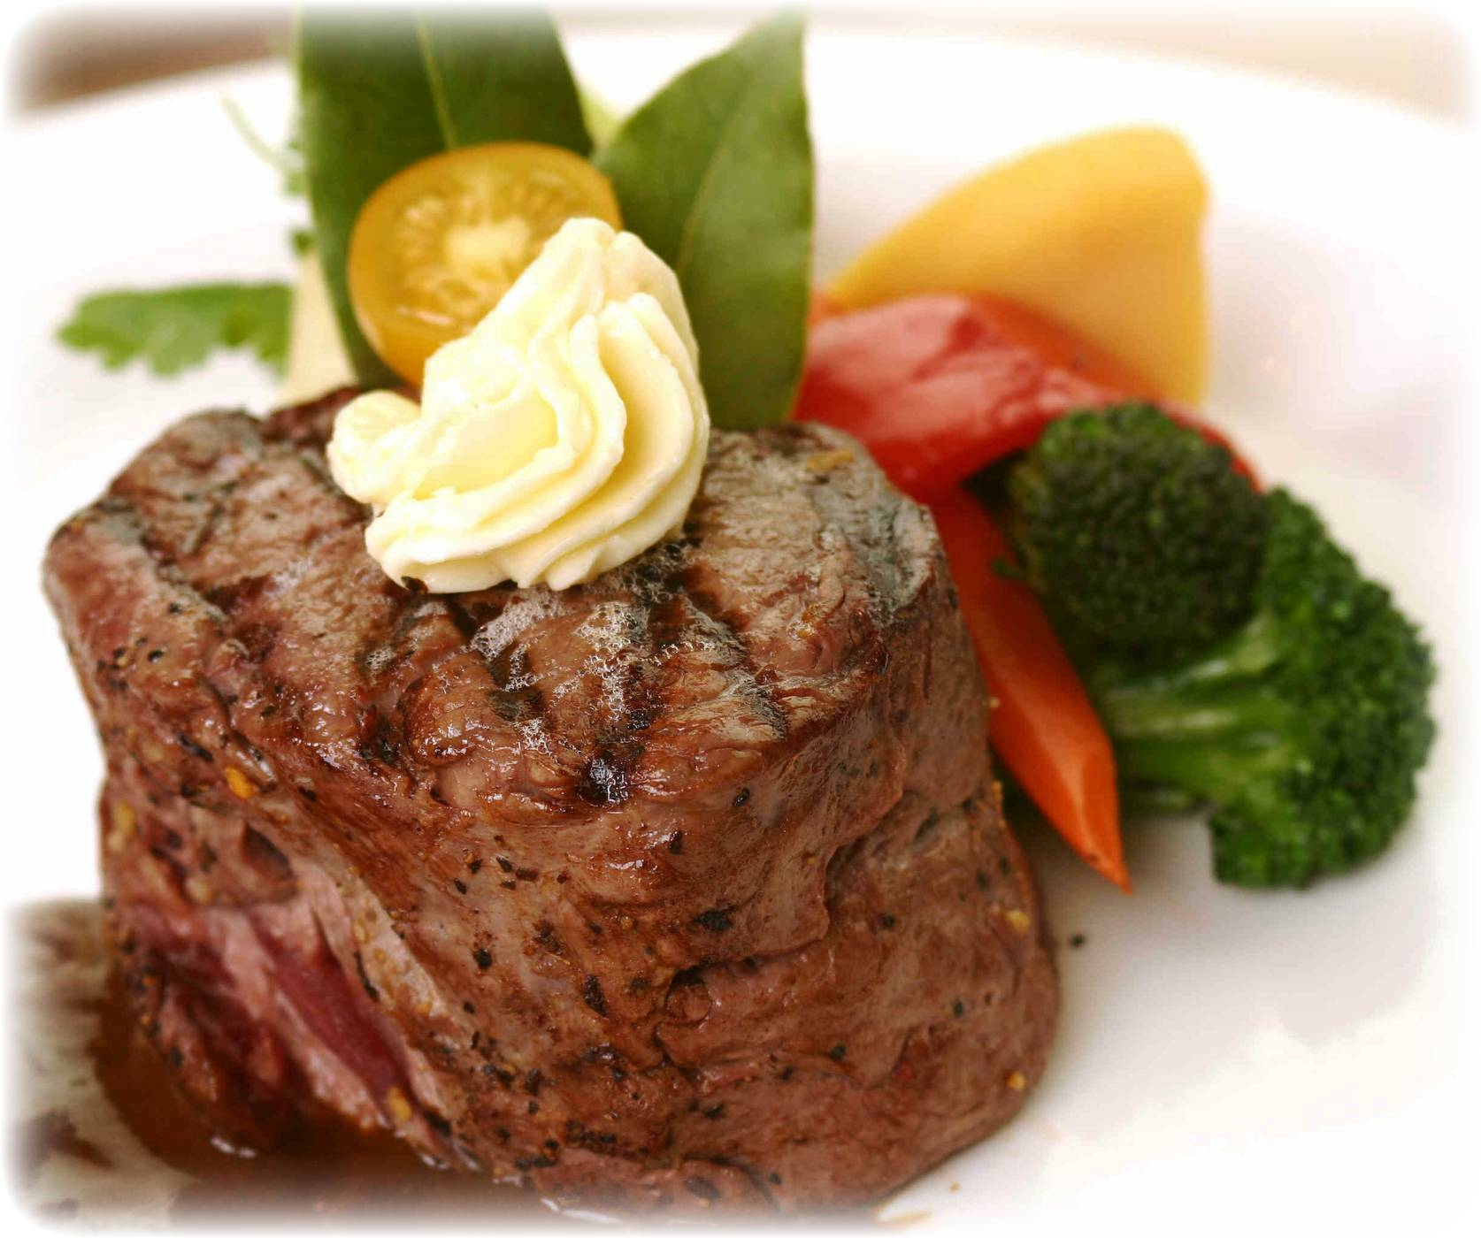

Baucom’s Best
100% Grass Fed Beef
Buying Club
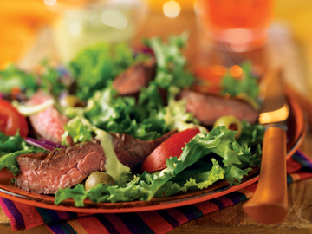

Benefits of Membership

Bulk Pricing without Bulk Buying
Buying Club Members enjoy Baucom’s Best 100% Grass Fed Beef and huge discounts without having to purchase large quantities of meat at one time. There is no need to have extra freezer space or write one big check. The only way to receive better pricing is to purchase an entire side of beef.

Being on a Budget never Tasted so Good
Buying Club Members know exactly what they will spend each month to provide their families with the healthiest beef available. Members, with average size families, can plan on creating 8 to 10 delicious meals a month all for one low price. Monthly Membership Fee is $94, which includes NC Sales Tax. The membership fee is fixed for 12 months, so retail price increases do not affect members.
Convenience
Buying Club Members receive a Beef Variety Pack once a month so they never have to worry about running out of quality beef or what’s for dinner. Our vacuum sealed packages thaw quickly and easily in cold water. If dinner plans change unexpectedly, 100% Grass Fed Beef’s higher levels of vitamin E will allow thawed meat to be stored safely in the refrigerator for weeks. Membership fees are billed automatically each month, so there is one less item on your “To Do List” and no need to stop at the ATM before heading to the Farmer’s Markets.
Variety
Buying Club Members enjoy all of the wonderful cuts we have to offer from Filet Mignon to Ground Beef, they get it all. Members are guaranteed to receive the following over the course of the year:

6 Filet Mignon Steaks 3 Sirloin Tip Roasts 2 Packages Cubed Steak
8 Rib Eye Steaks 2 Top Round Roasts 8 Packages of Short Ribs
6 NY Strip Steaks 3 Chuck Roasts 8 Soup Bones
10 Sirloin Steaks 1 Bottom Round Roast 1 Brisket (Half size)
6 Flank Steaks 2 Shoulder Roast 6 Packages of Patties
2 Skirt Steaks 12 Packages Stew Beef 72 Packages of Ground Beef

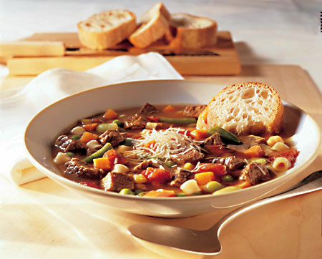
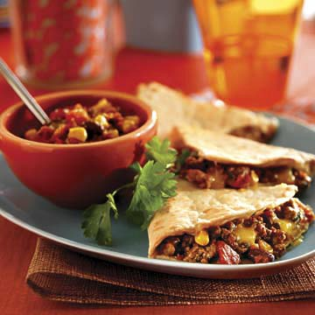
Sample
Variety Pack

2 Rib Eye Steaks
1 Flank Steak
1 Top Round Roast
1 Package of Stew Beef
1 Package of Patties
(4 per Pack)
6 packs Ground Beef

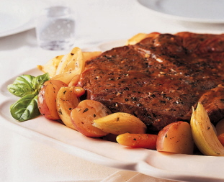

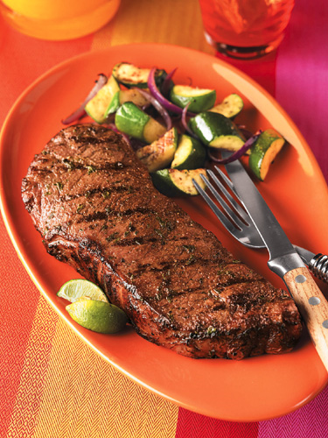
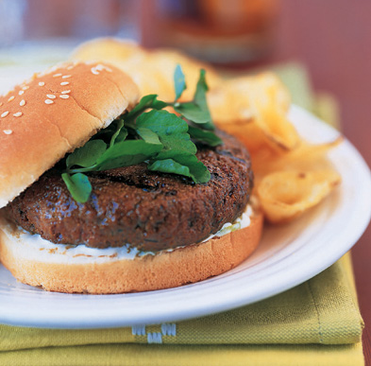
Membership Details
- All memberships are for 12 consecutive months.
- Membership Fee is automatically billed each month.
- The monthly membership fee is at a fixed amount for the entire year, fee will not be raised during the year.
- Monthly membership fee already includes 2% Sales Tax.
- Each month members will receive Beef Variety Pack.
Variety Pack will consist of Premium Steaks, roasts, Ground Beef, etc. and will weigh just over 15 pounds.
- Members must pick up Variety Packs at local Farmer’s Markets, On-Farm or at Designated Pick-Up locations. Shipping is available for an additional charge.
- Variety Packs will be put together each month at the discretion of Baucom’s Best.
- Members will receive just over 183 pounds of 100% Grass Fed Beef annually.

A limited number of Buying Club Memberships are available each year.
They will be assigned on a first come first serve basis.

For more information
or to join please call:
704-254-0742
Or email us at:
info@baucomsbest.com


